1. Construct a decision tree from the data [30 points].

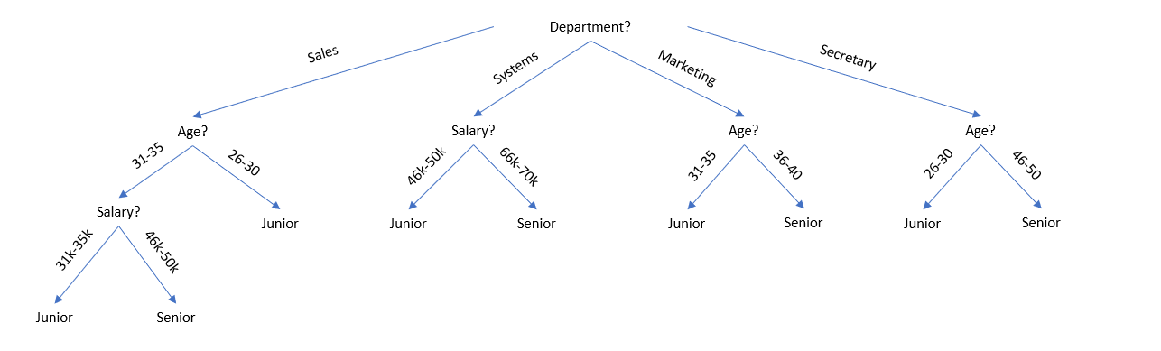

2. For the following test data, what would be the class label prediction using the Naive Bayesian classification method? [30 points]

- <systems, 26...30,46-50k>

Let X = <systems, 26...30,46-50k>

In the data given to us, there is no senior within the ages of 26 through 30.

Therefore, P(X|Senior) = 0.

P(X|Junior) = 3 / (30 + 40 +40 + 20 + 5 + 3 + 3 + 10 + 4 + 4 + 6) = 3 / 165 = 0.018.

Therefore, the class label predicted by the Naïve Bayesian classification method would be junior.